**Number Ranges and Account Determination**

**Account Determination**

Step 1: Navigate through the following path

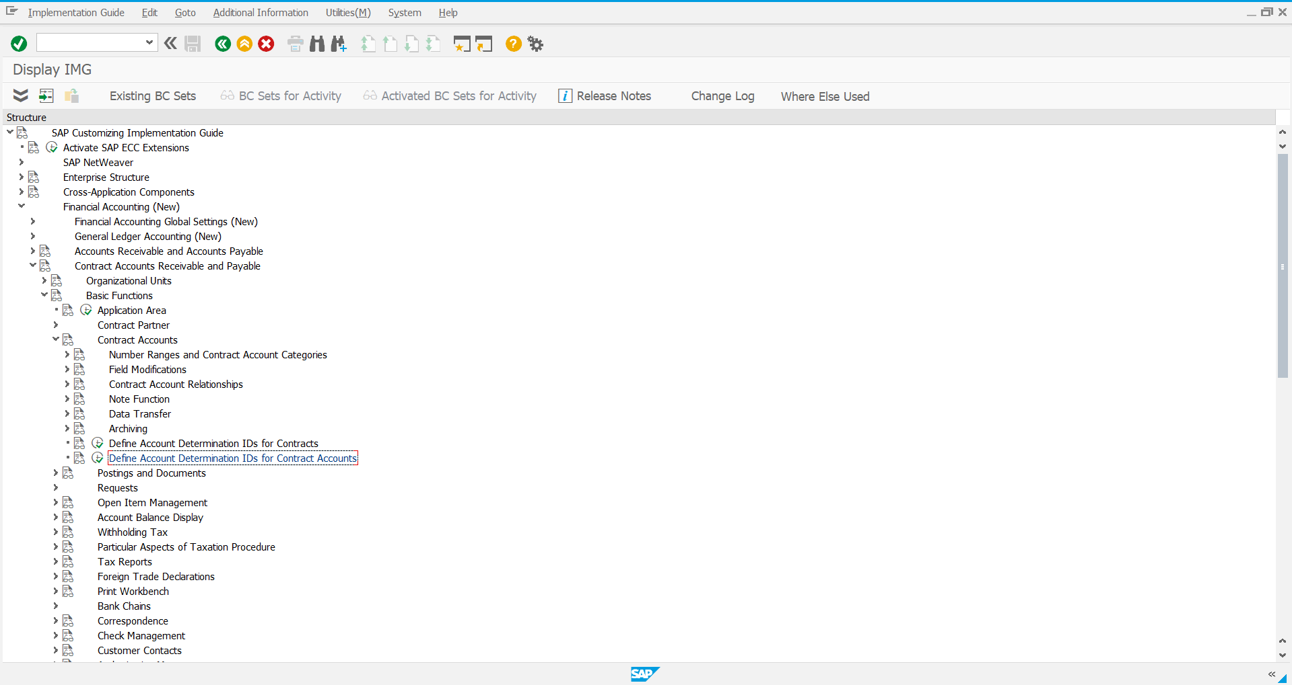

Step 2: Select **New Entries** in the following screen

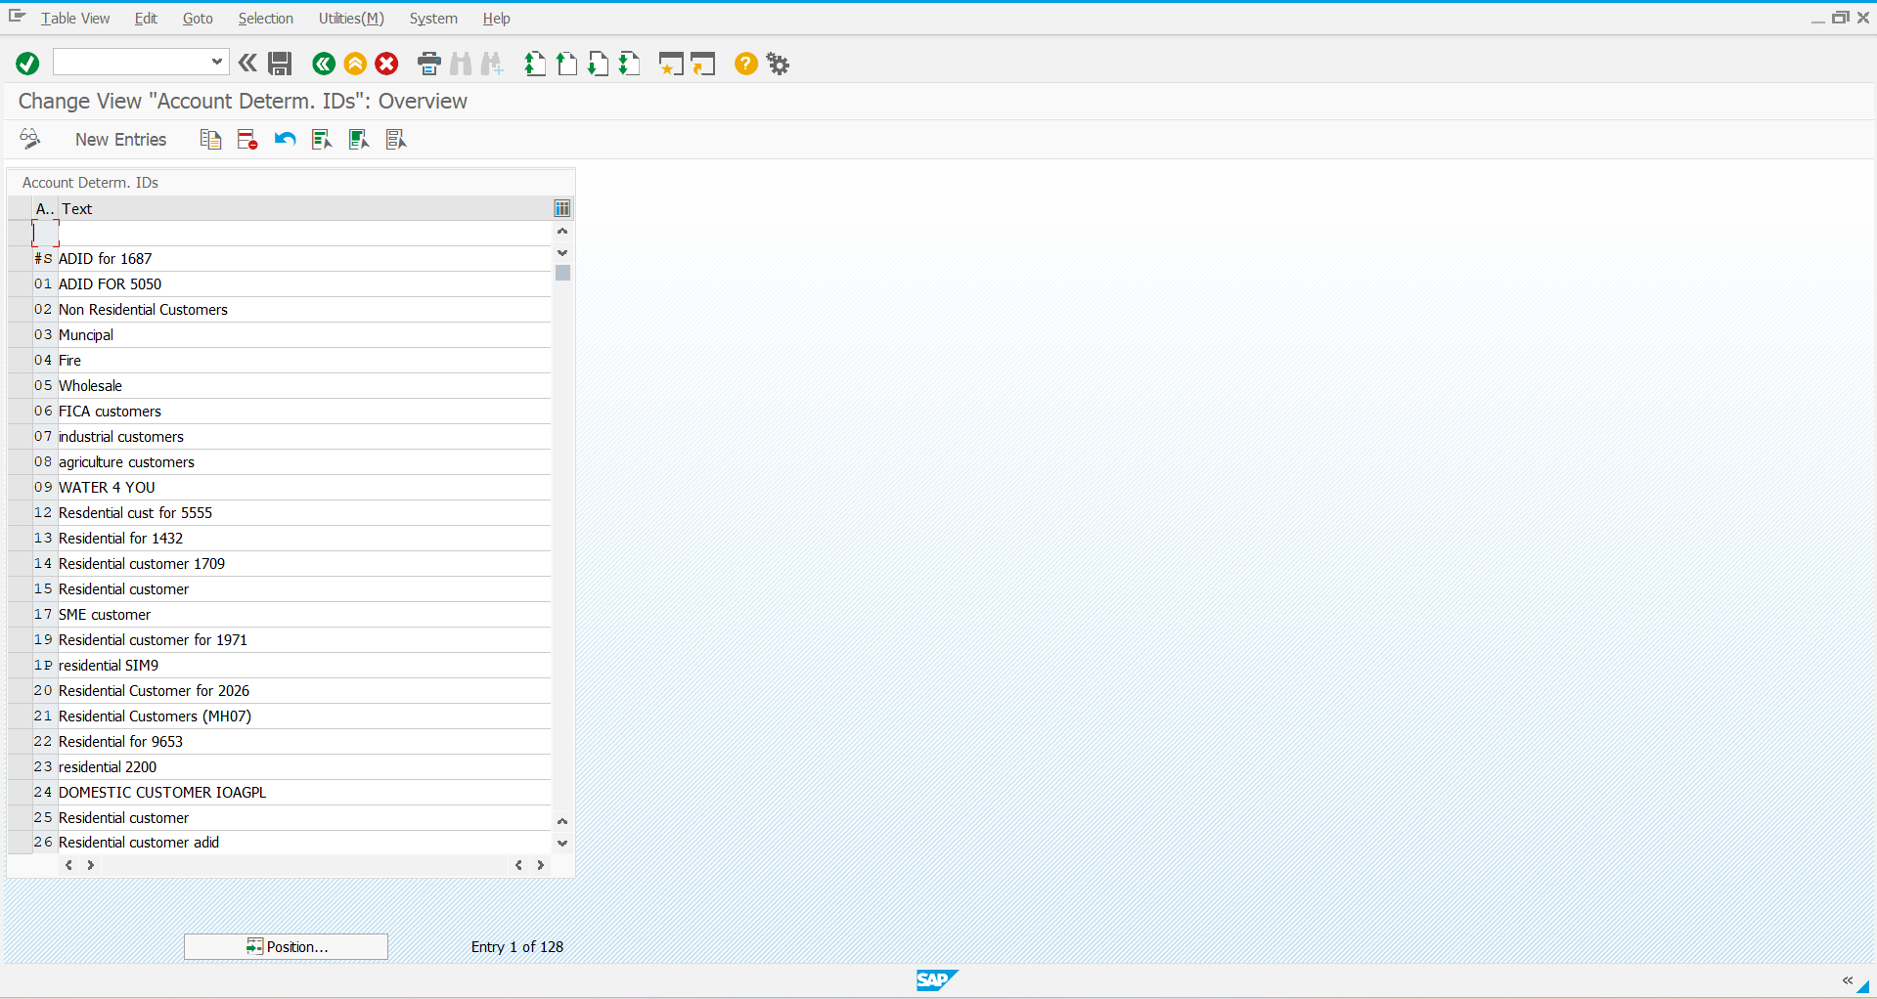

Step 3: Enter the required information and Save it

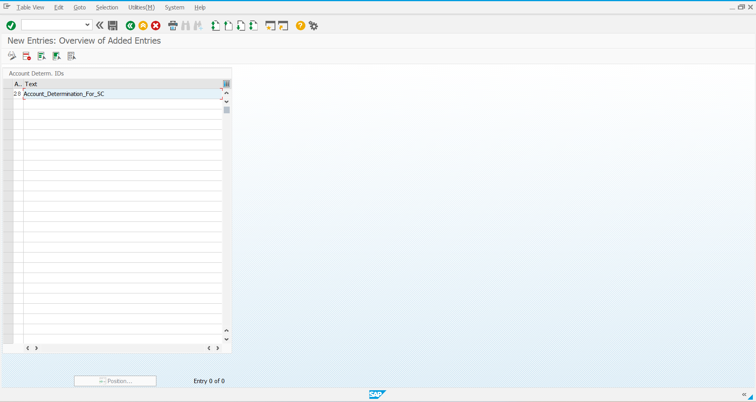

Step 4: Account Determination ID created

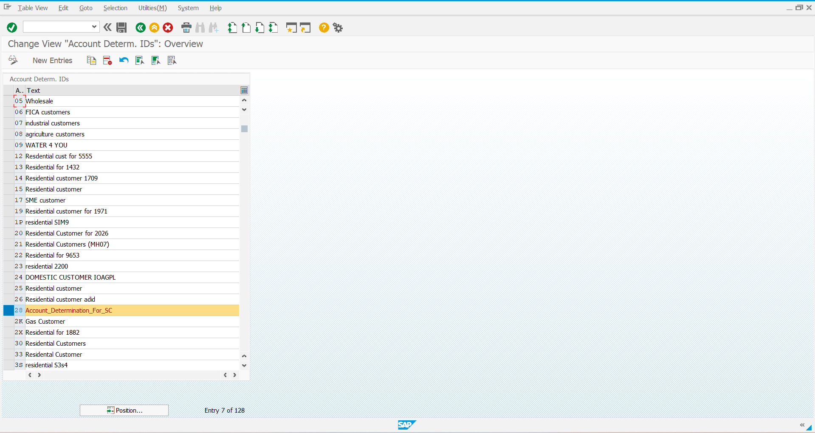

**Number Range**

**T Code:** FBN1

Step 1: Using the above T Code Navigate to the following Screen and provide the Company Code

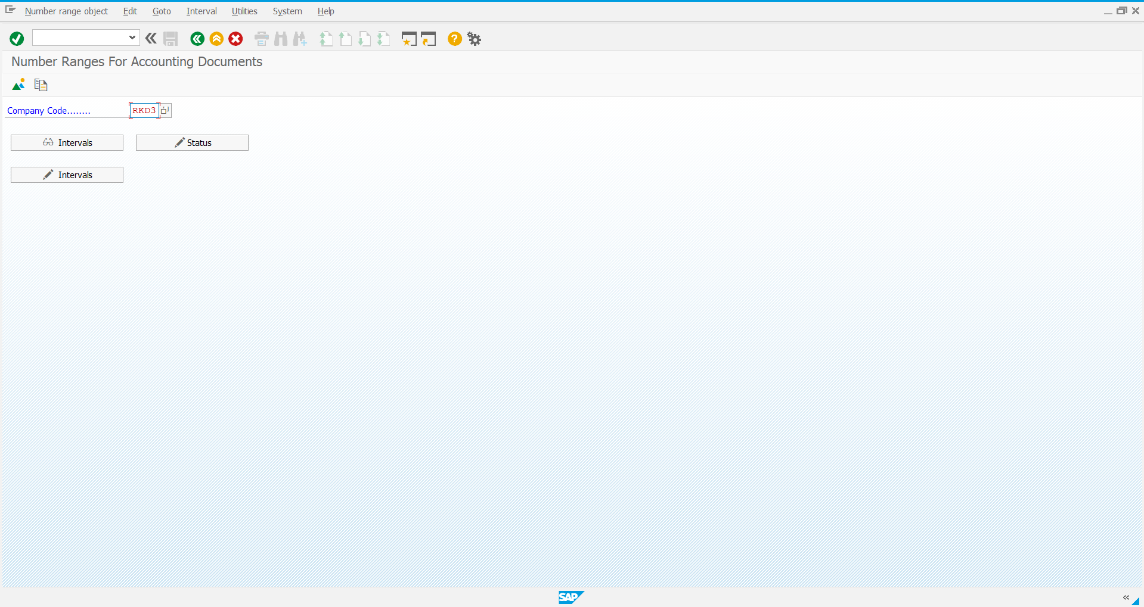

Step 2: Define the intervals by using the option available in the next screen

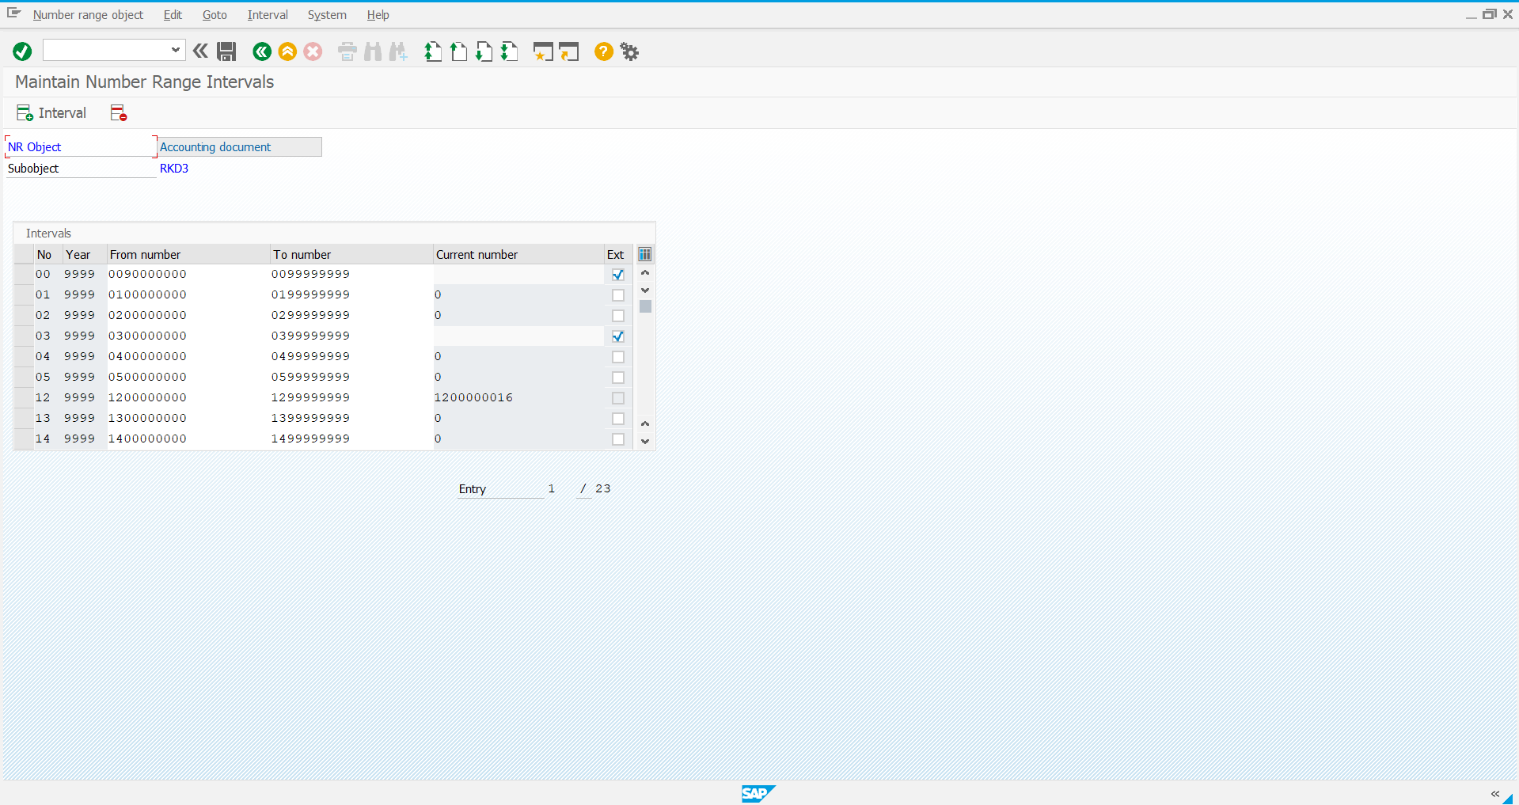

Step 3: Enter the details required details

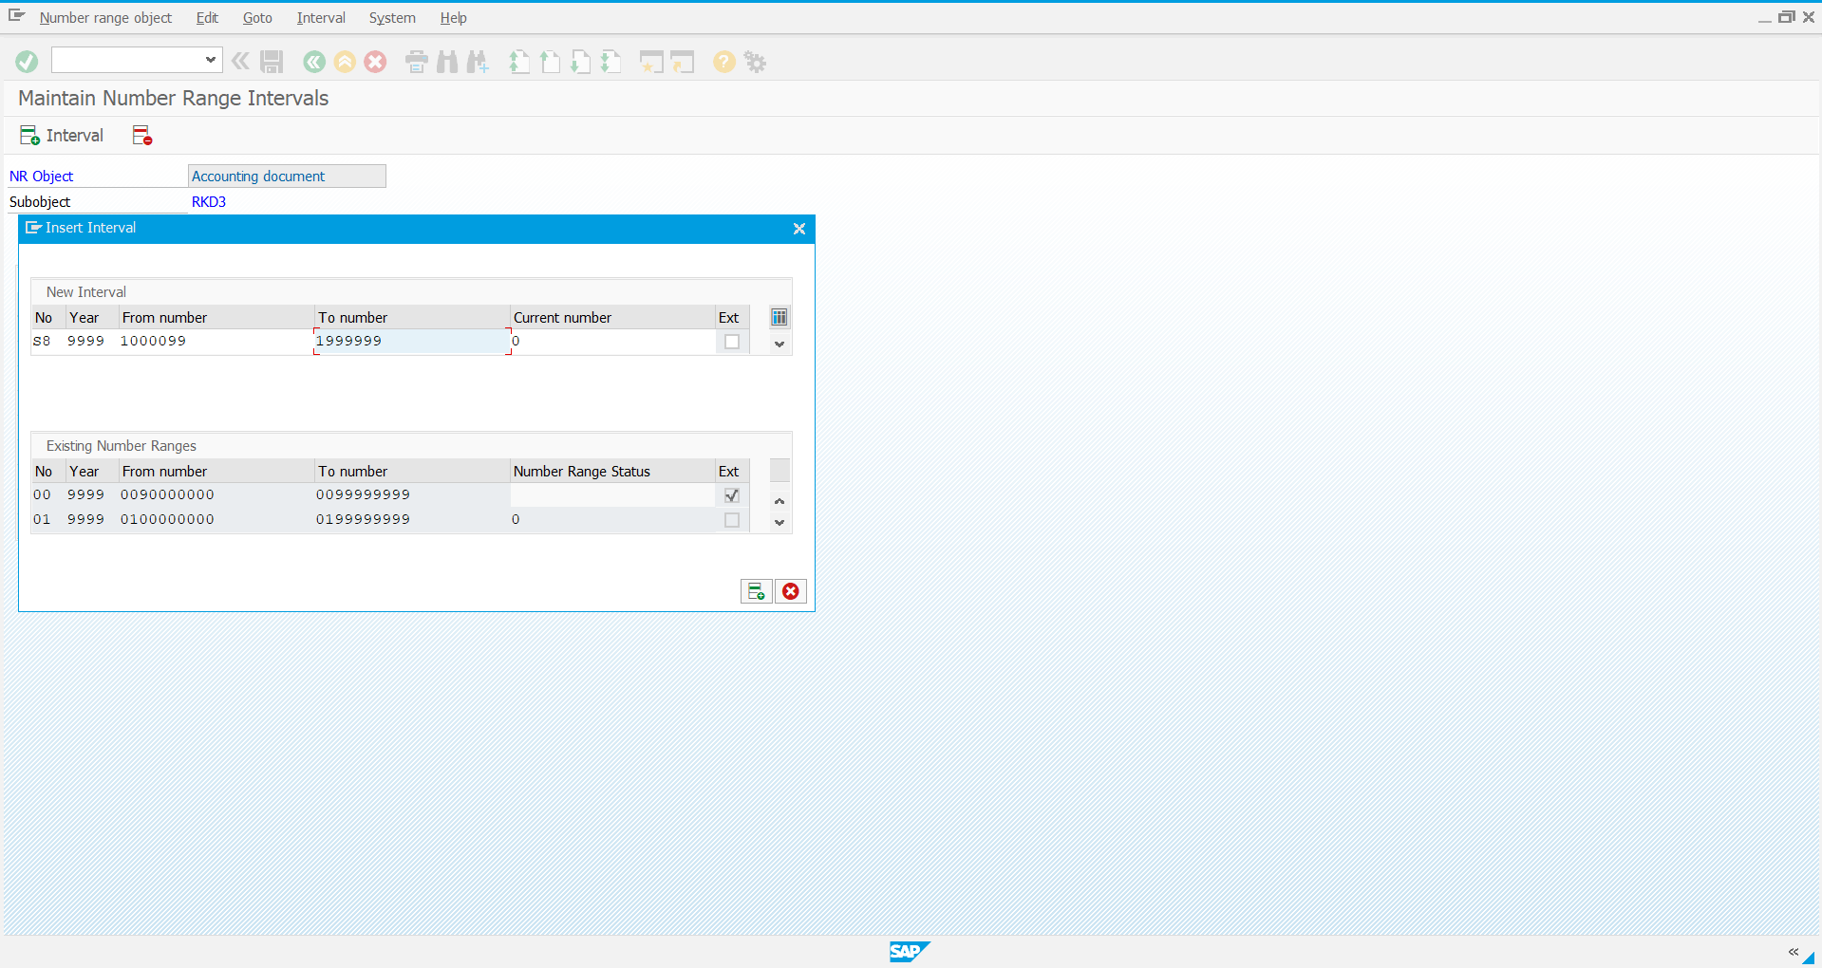

Step 4: Save it

